**Week 7 Hands On Practice Solutions**

**REACT . JS**

1. **ReactJS-HOL**

Create a React Application named “cricketapp” with the following components.

Step 1: To create a React Application with the name of “cricketapp”, type the following command:

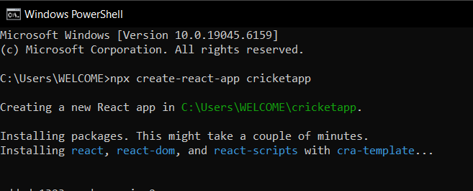

Step 2: Once the App is created, navigate into the folder of cricketapp by typing the following command:

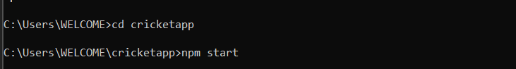

Step 3: Open the folder of cricketapp in Visual Studio Code

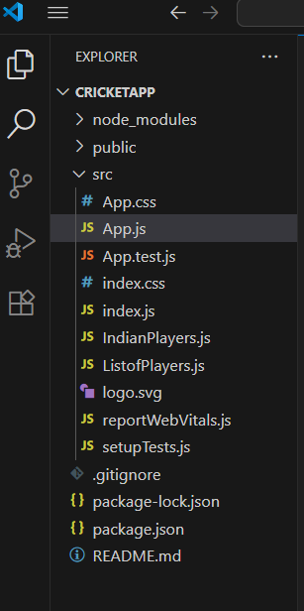

Step 4: Open the ListofPlayers.js file in Src Folder of cricketapp.Write the Code:

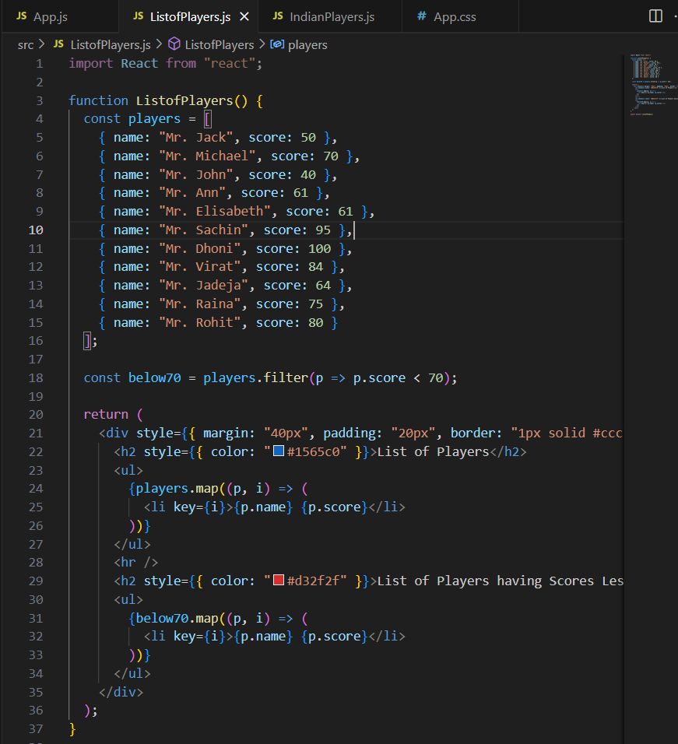

Step 5: Open the IndianPlayers.js file in Src Folder of cricketapp .Write the Code.

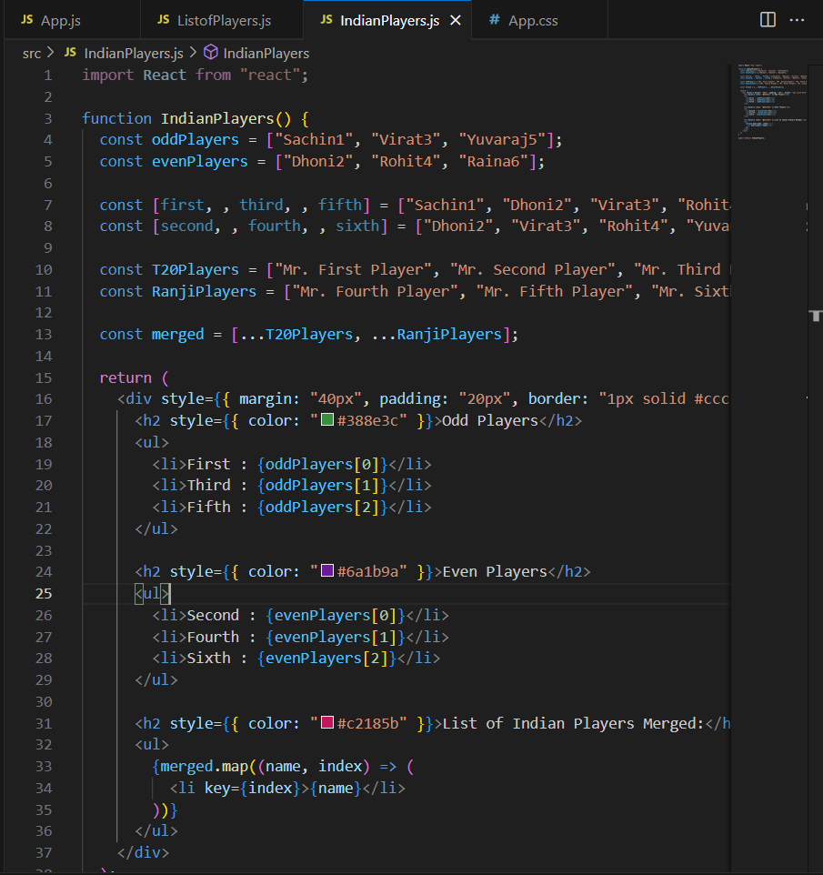

Step 6: Open the App.js file in Src Folder of cricketapp .Write the Code

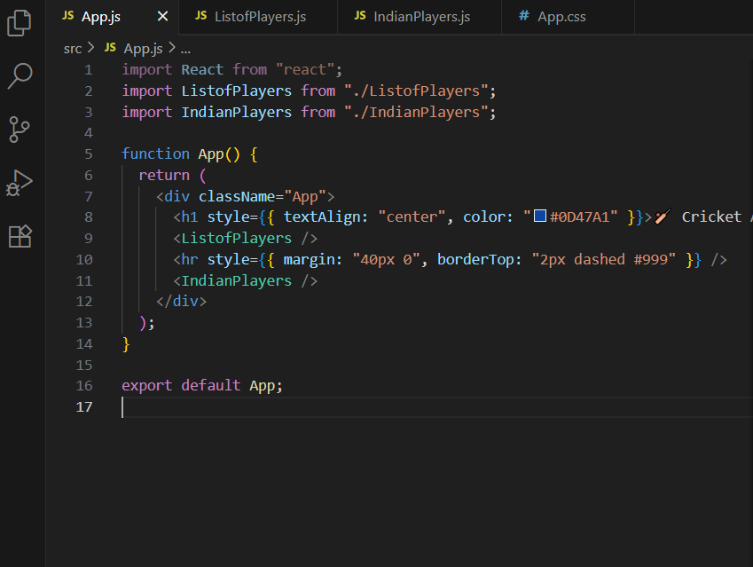

Step 7: Open the App.css file in Src Folder of cricketapp .Write the Code

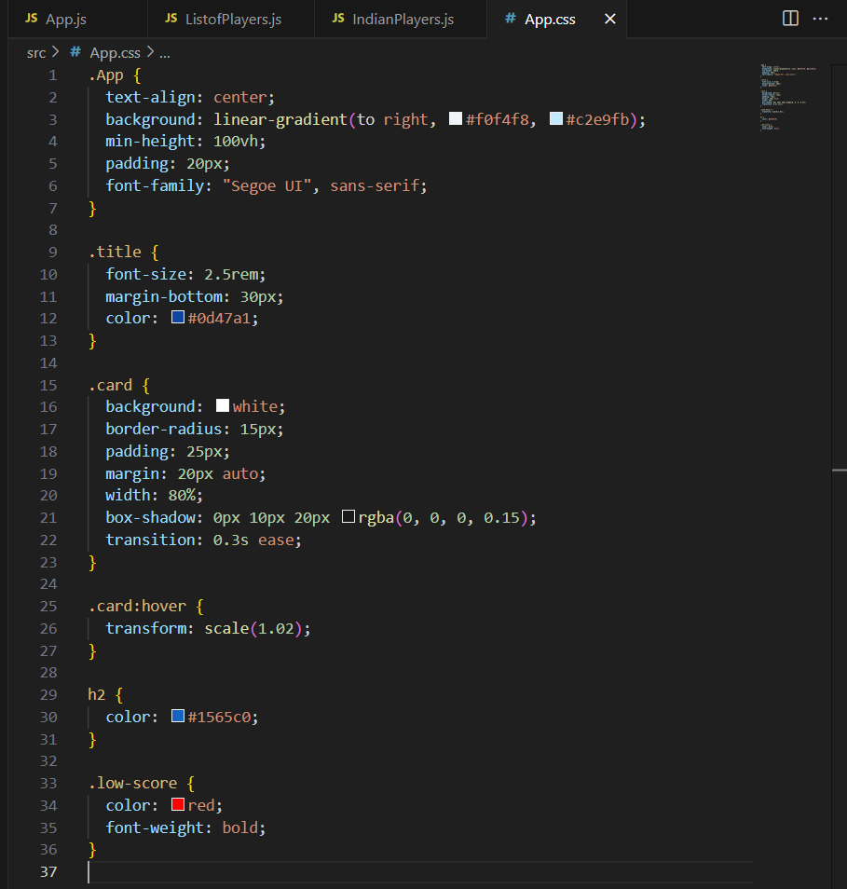

Step 8: Run the following command to execute the React application:

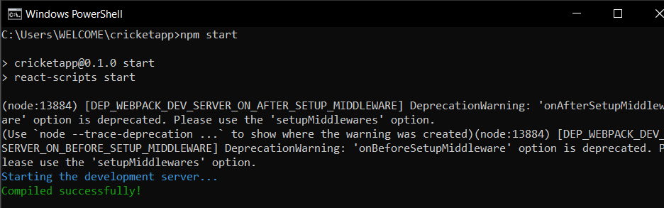

Step 9: Open a new browser window and type “localhost:3000” in the address bar

**Output:**

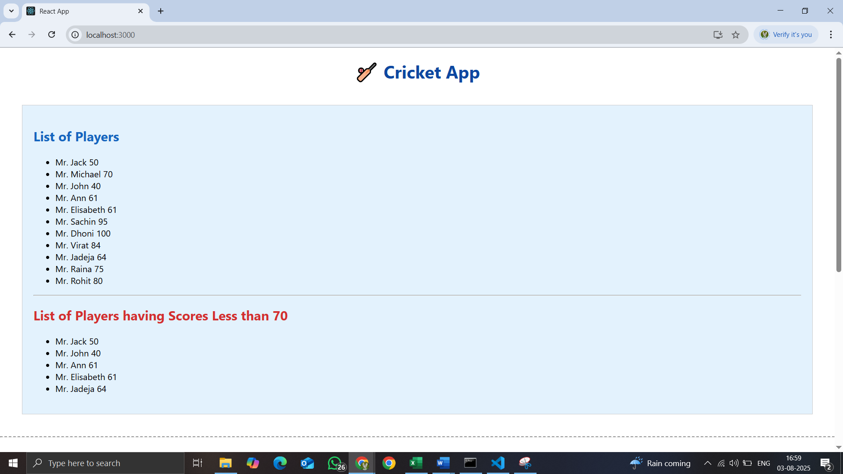

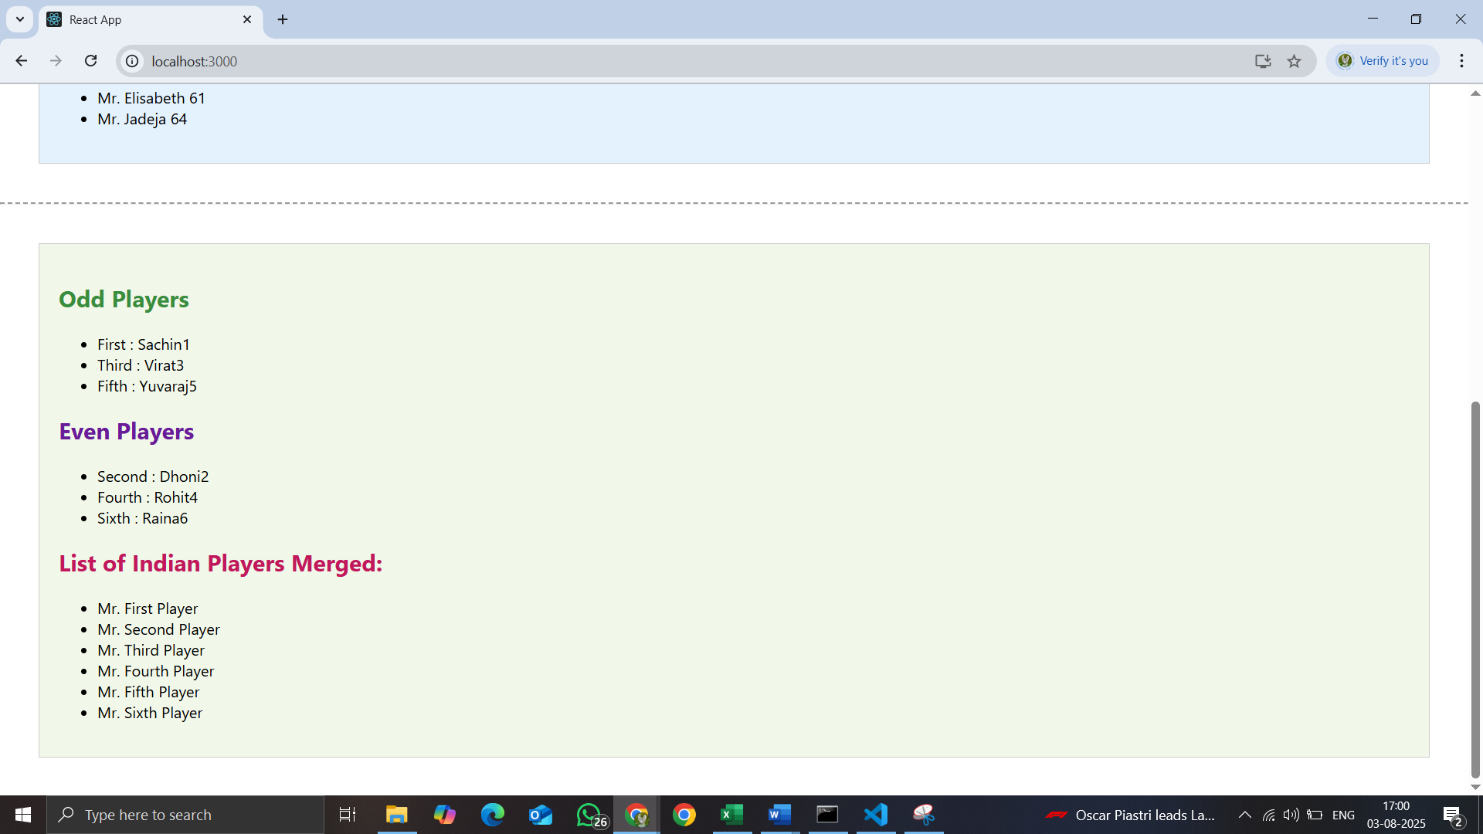

1. **ReactJS-HOL**

Create a React Application named “officespacerentalapp” which uses React JSX to create elements, attributes and renders DOM to display the page.

Step 1: To create a React Application with the name of “officespacerentalapp”, type the following command:

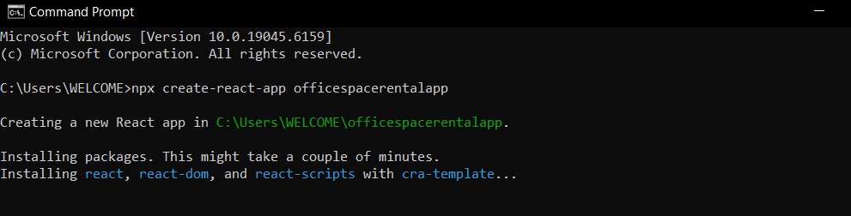

Step 2: Once the App is created, navigate into the folder of officespacerentalapp by typing the following command:

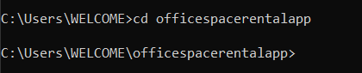

Step 3: Open the folder of officespacerentalapp in Visual Studio Code

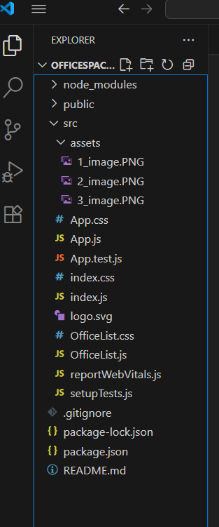

Step 4: Open the officelist.js file in Src Folder of officespacerentalapp.Write the Code:

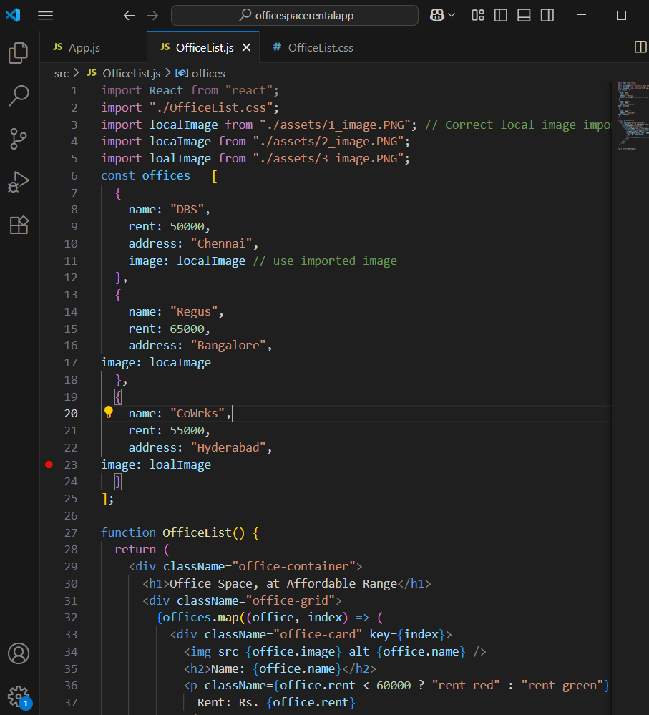

Step 5: Open the officelist.css file in Src Folder of officespacerentalapp.Write the Code.

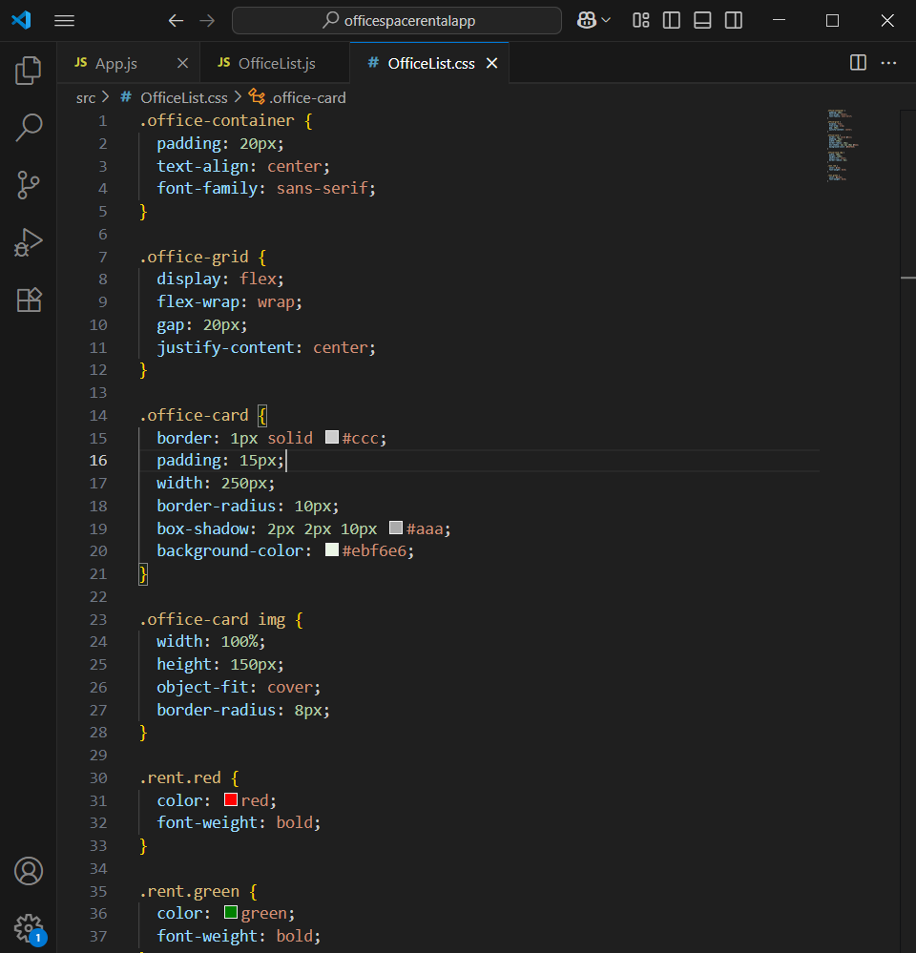

Step 6: Open the App.js file in Src Folder of officespacerentalapp.Write the Code

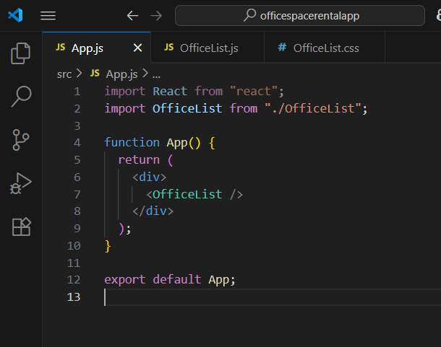

Step 7: Run the following command to execute the React application:

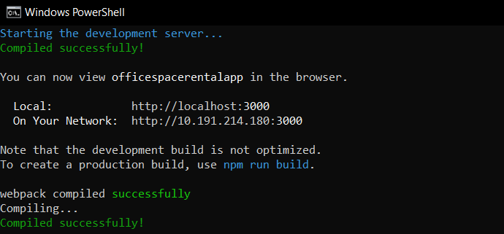

Step 8: Open a new browser window and type “localhost:3000” in the address bar

**Output:**

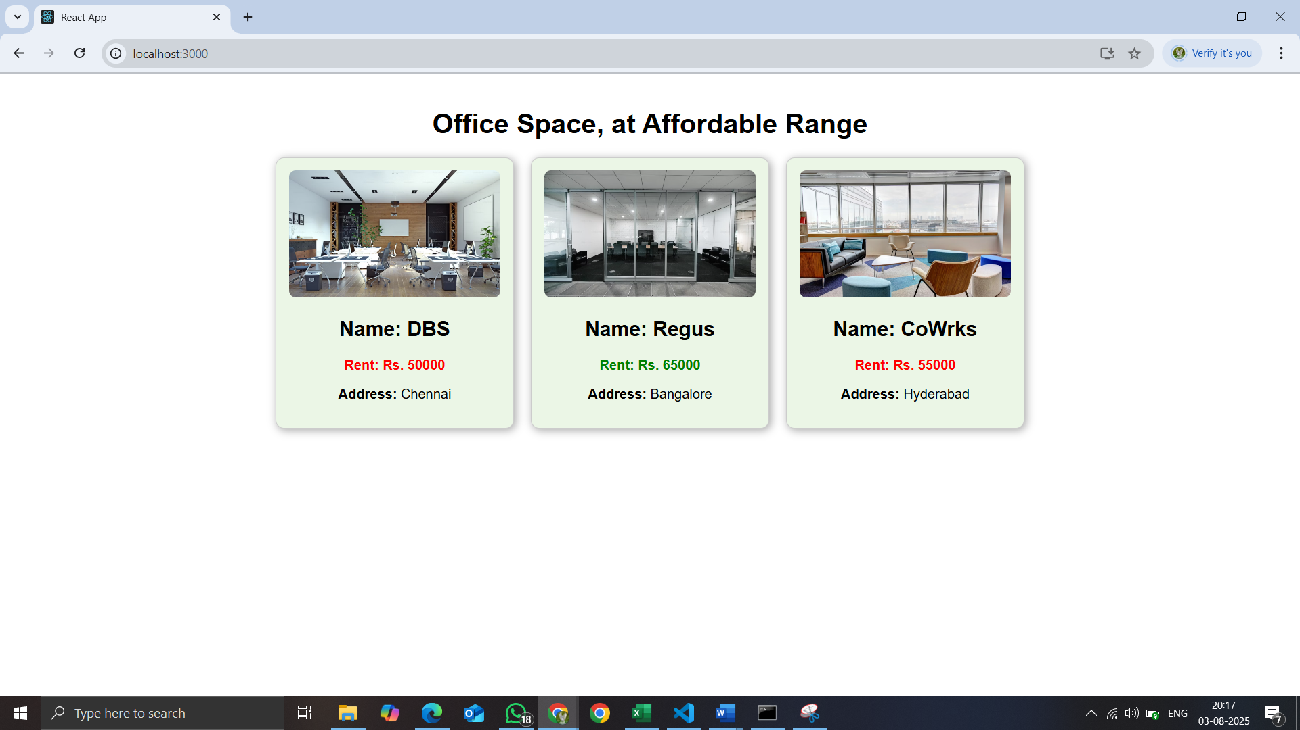

1. **ReactJS-HOL**

Create a React Application “eventexamplesapp” to handle various events of the form elements in HTML.

Step 1: To create a React Application with the name of “eventexamplesapp”, type the following command:

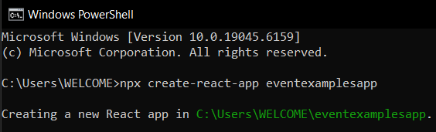

Step 2: Once the App is created, navigate into the folder of eventexamplesapp by typing the following command:



Step 3: Open the folder of eventexamplesapp in Visual Studio Code

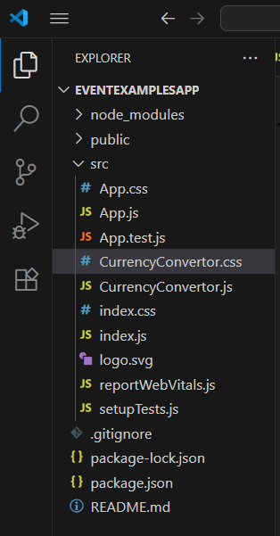

Step 4: Open the App.js file in Src Folder of officespacerentalapp.Write the Code.

1. Create “Increment” button to increase the value of the counter and “Decrement” button to decrease the value of the counter. The “Increase” button should invoke multiple methods.
   1. To increment the value
   2. Say Hello followed by a static message.
2. Create a button “Say Welcome” which invokes the function which takes “welcome” as an argument.
3. Create a button which invokes synthetic event “OnPress” which display “I was clicked”

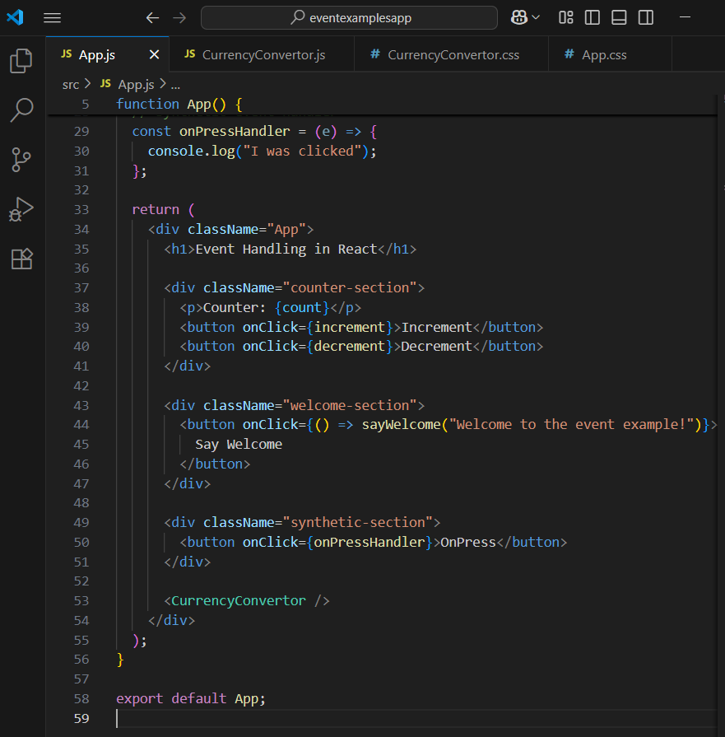

Step 5: Create a “CurrencyConvertor” component which will convert the Indian Rupees to Euro when the Convert button is clicked.

Handle the Click event of the button to invoke the handleSubmit event and handle the conversion of the euro to rupees.

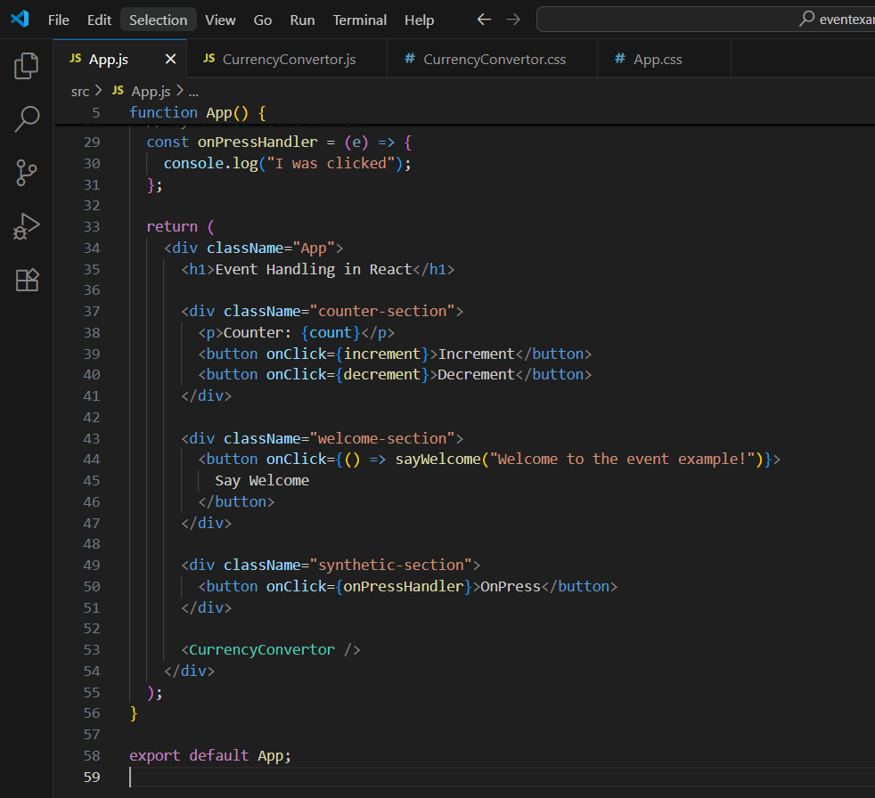

Step 6: Run the following command to execute the React application:



Step 7: Open a new browser window and type “localhost:3000” in the address bar

**Output:**

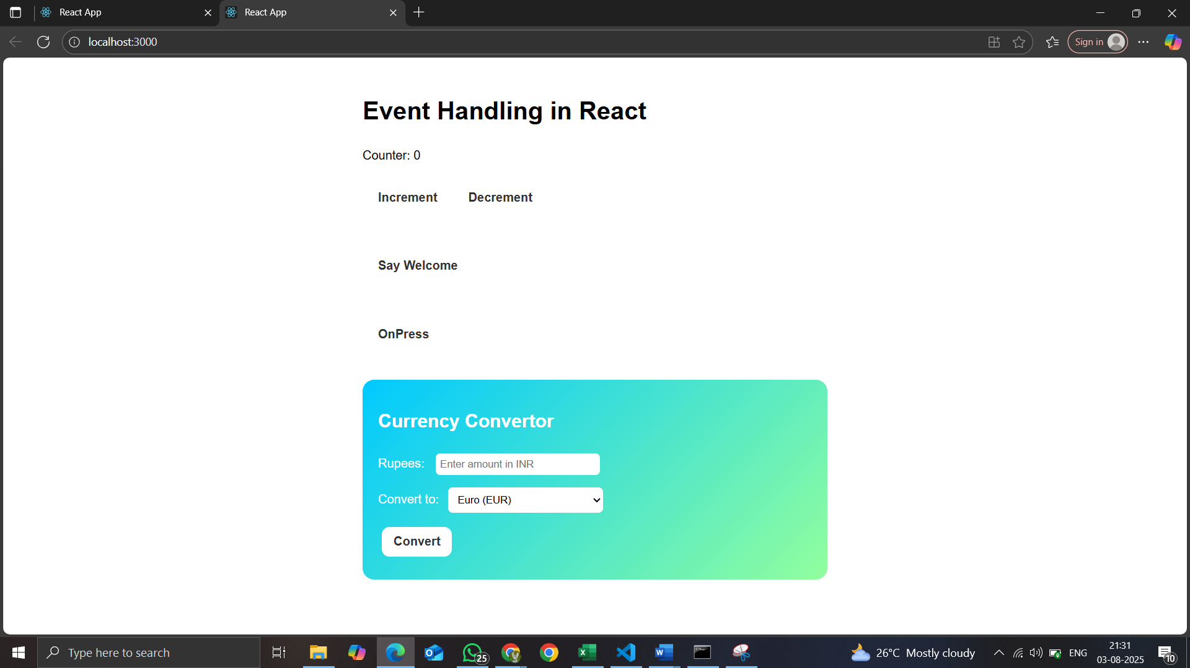

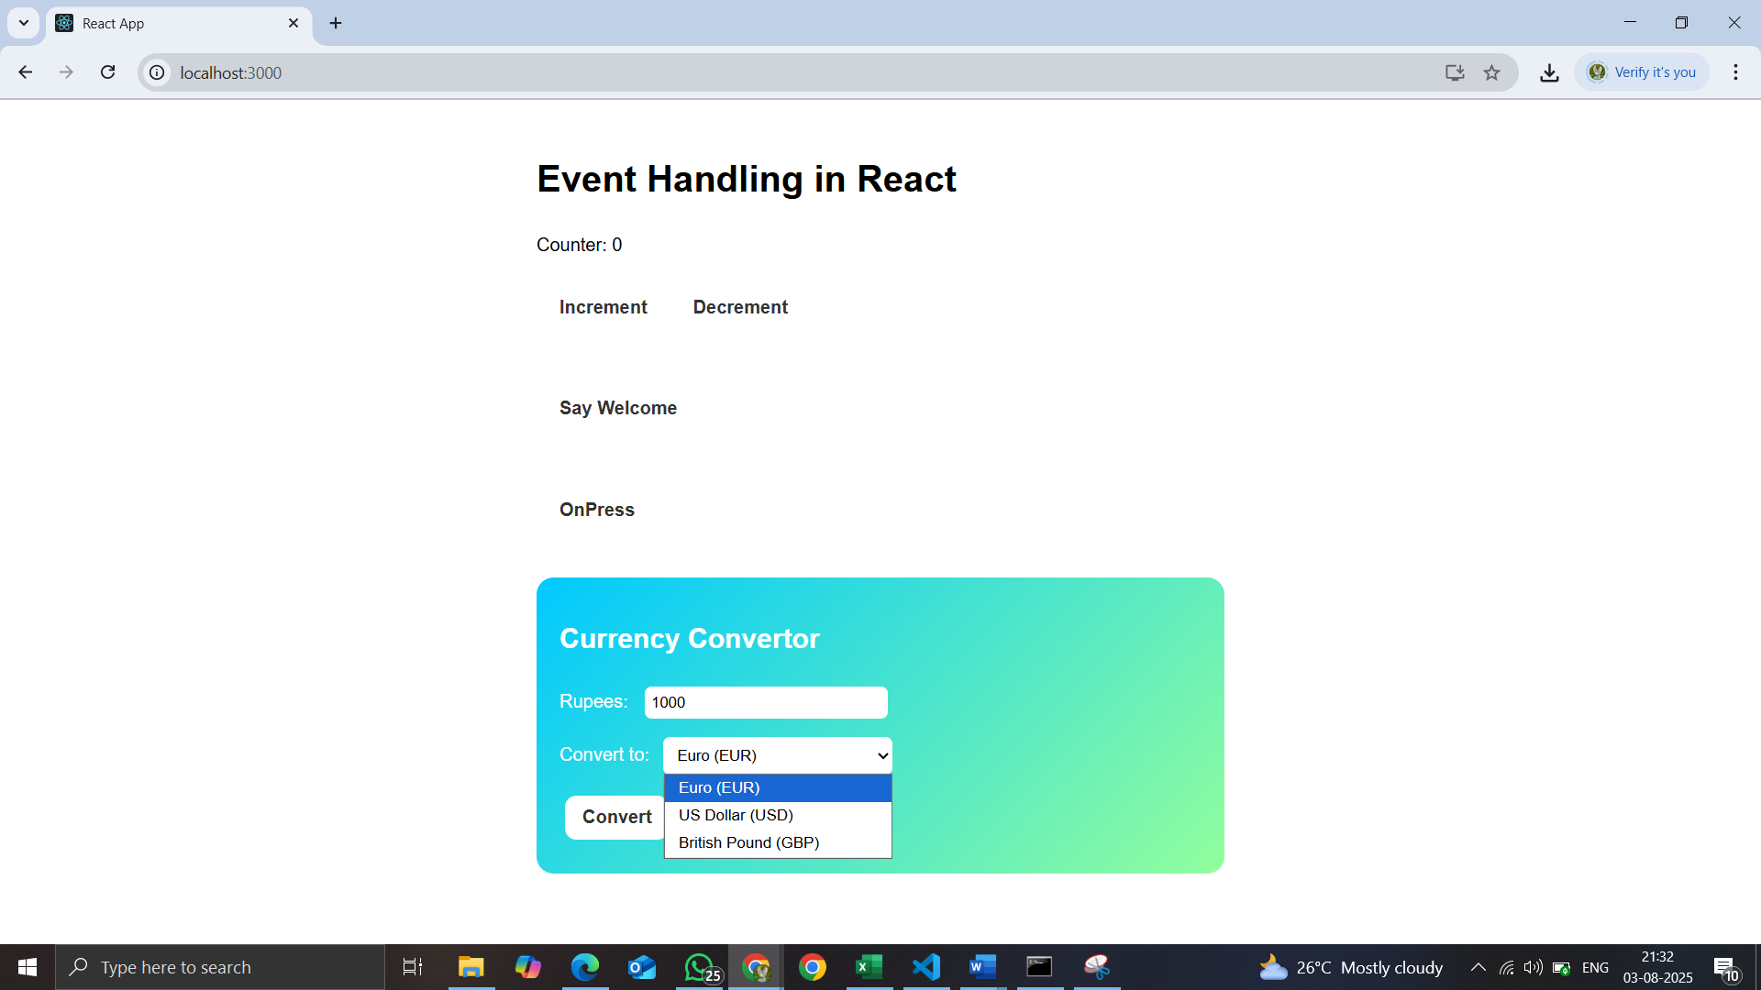

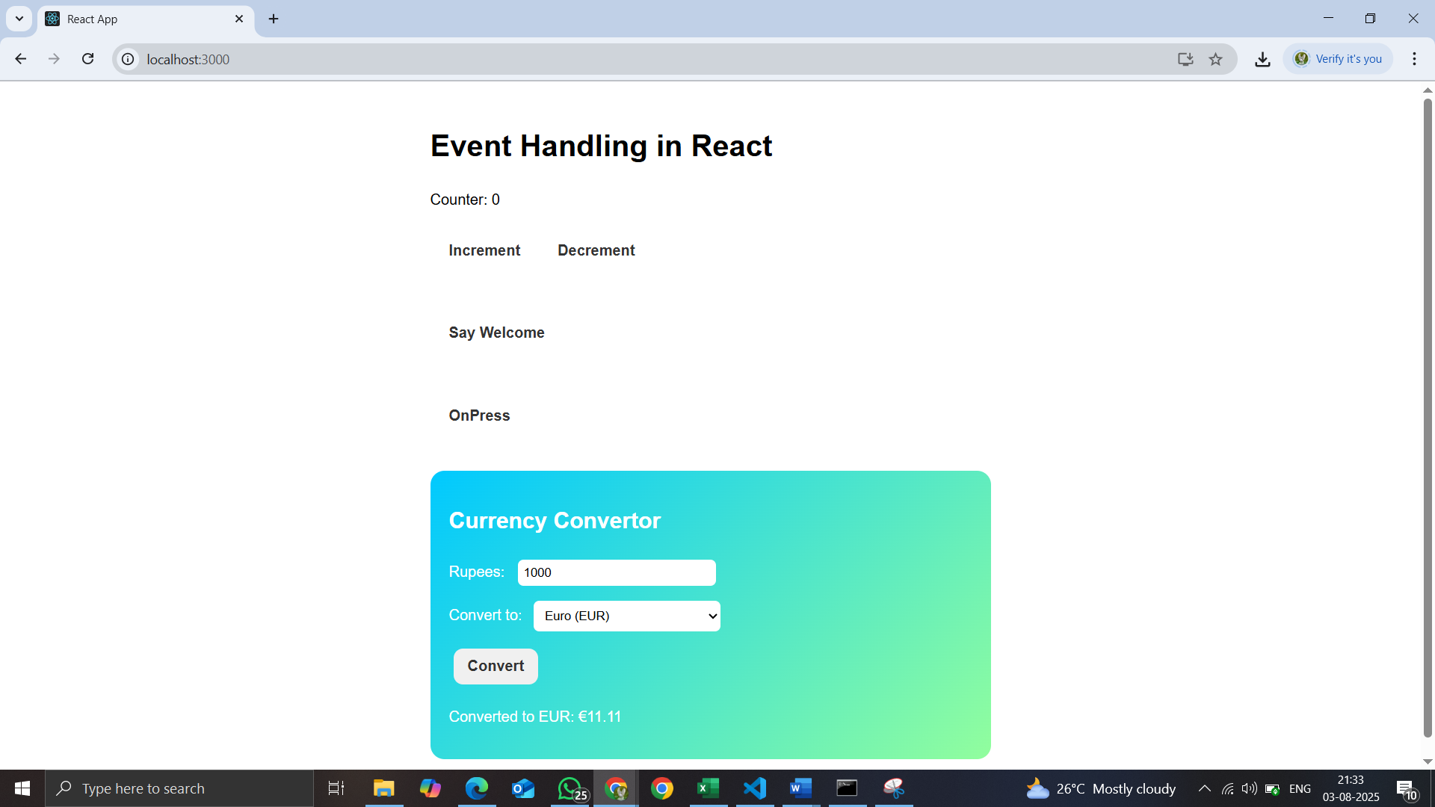

1. **ReactJS-HOL**

Create a React Application named “ticketbookingapp” where the guest user can browse the page where the flight details are displayed whereas the logged in user only can book tickets.

Step 1: To create a React Application with the name of “ticketbookingapp”, type the following command:

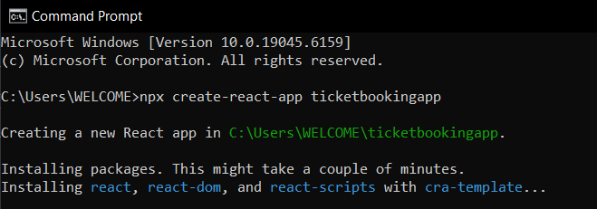

Step 2: Once the App is created, navigate into the folder of ticketbookingapp by typing the following command:



Step 3: Open the folder of ticketbookingapp in Visual Studio Code

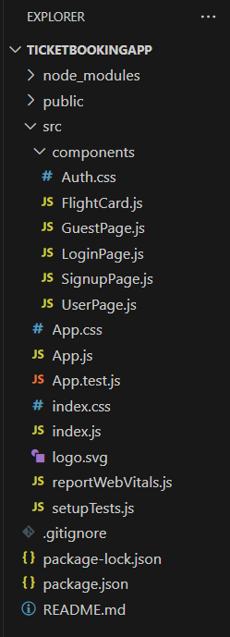

Step 4: Create files structure like :

ticketbookingapp/

├── public/

├── src/

│ ├── components/

│ │ ├── GuestPage.js

│ │ ├── UserPage.js

│ │ ├── LoginPage.js

│ │ ├── SignupPage.js

│ │ ├── FlightCard.js

│ ├── App.js

│ ├── index.js

│ ├── App.css

└── package.json

Step 5: Open the GuestPage.js file in Src Folder of ticketbookingapp.Write the Code:

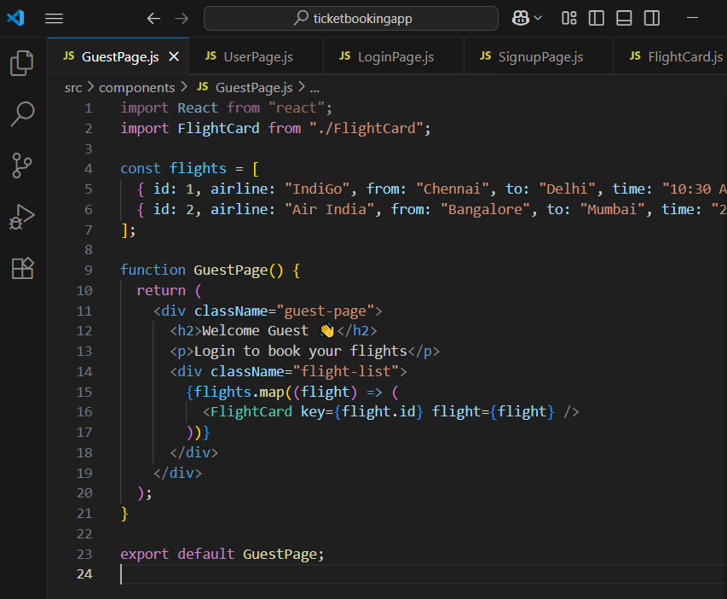

Step 6: Open the UserPage.js file in Src Folder of ticketbookingapp.Write the Code. 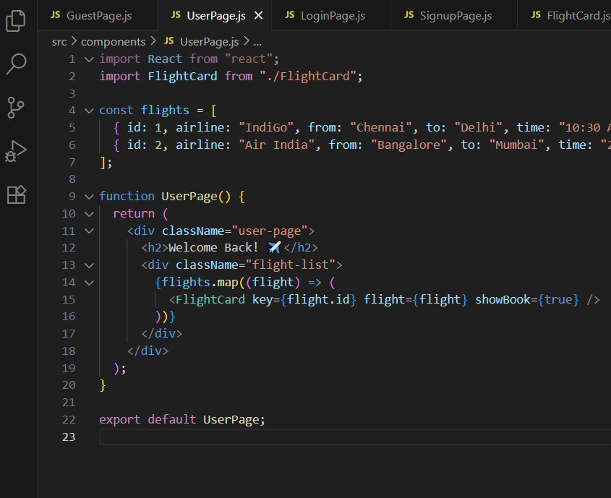

Step 7: Open the LoginPage.js file in Src Folder of ticketbookingapp.Write the Code.

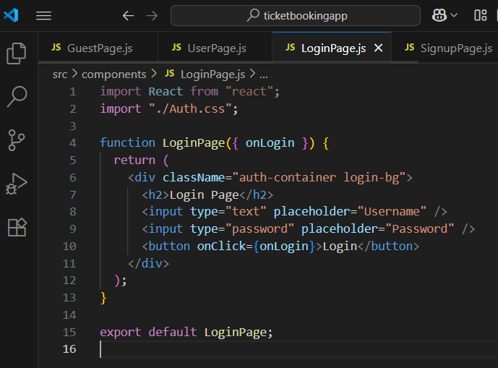

Step 8: Open the SignupPage.js file in Src Folder of ticketbookingapp.Write the Code.

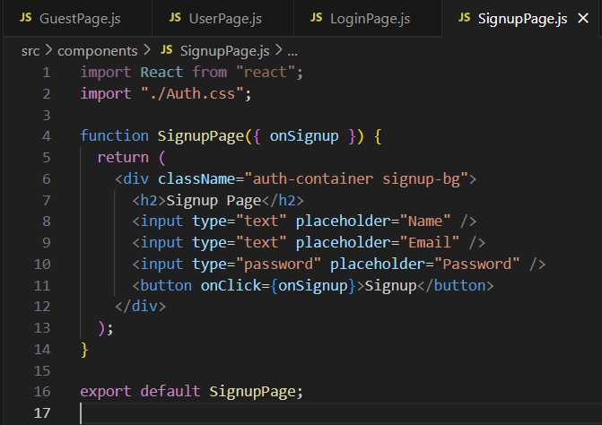

Step 9: Open the FlightCard.js file in Src Folder of ticketbookingapp.Write the Code.

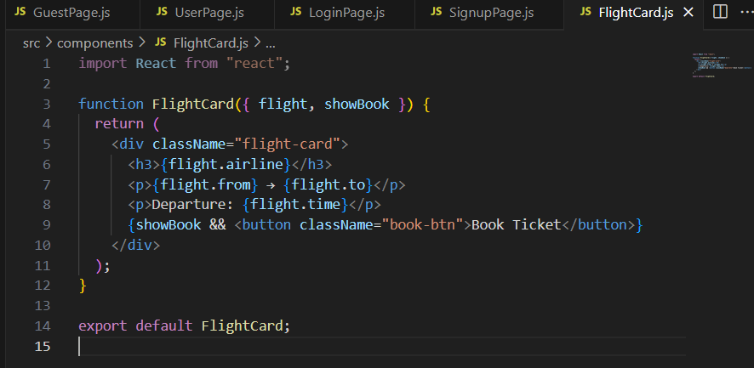

Step 10: Open the Auth.css file in Src Folder of ticketbookingapp.Write the Code.

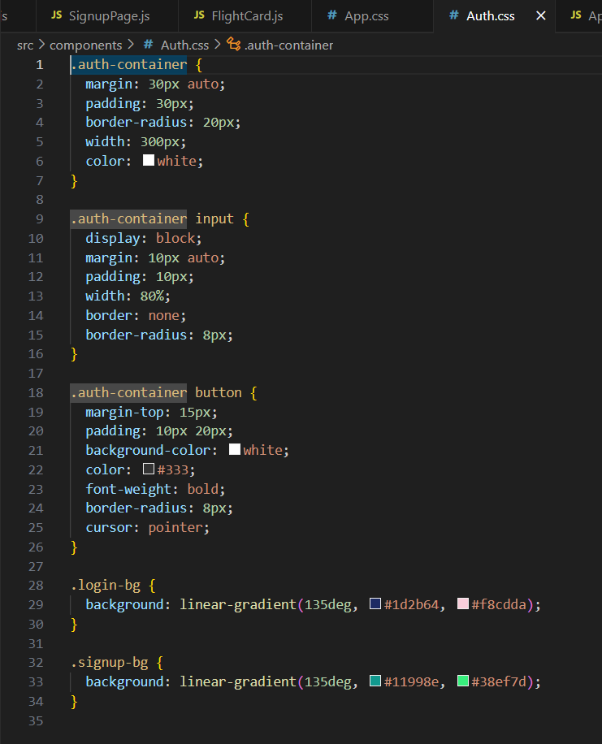

Step 11: Open the App.js file in Src Folder of ticketbookingapp.Write the Code

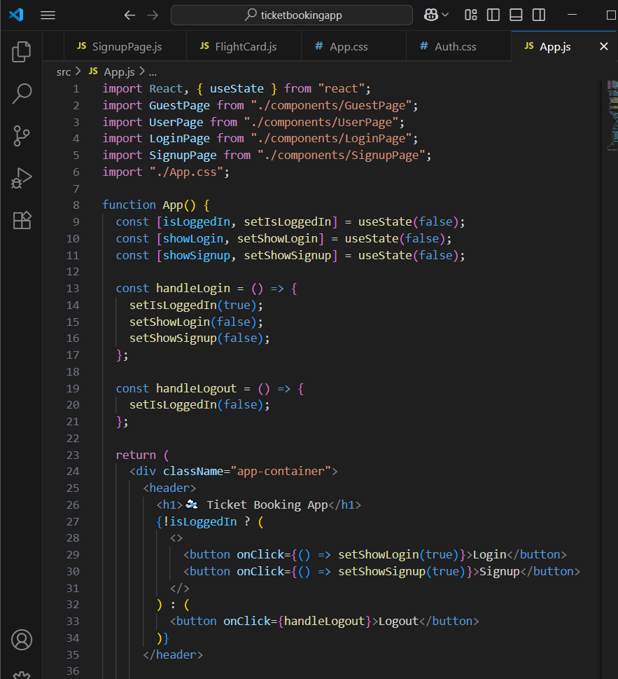

Step 12: Open the App.css file in Src Folder of ticketbookingapp.Write the Code

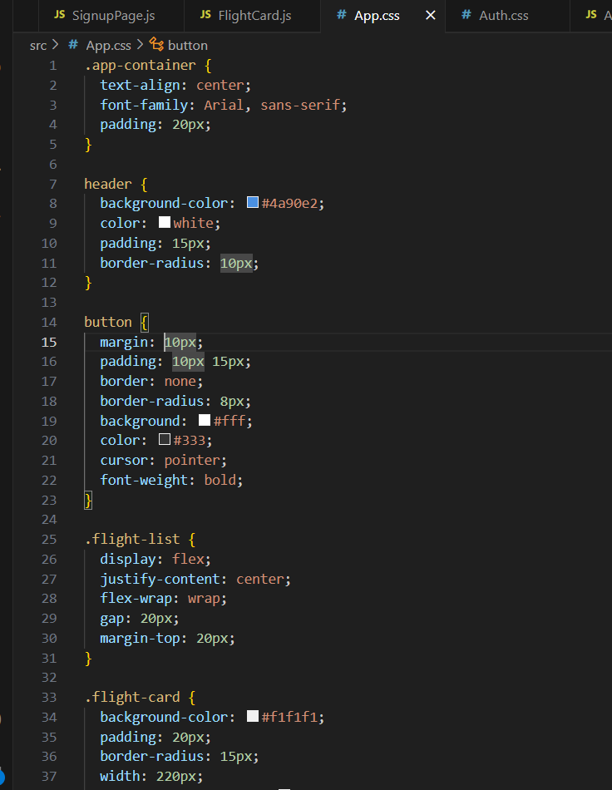

Step 8: Run the following command to execute the React application:

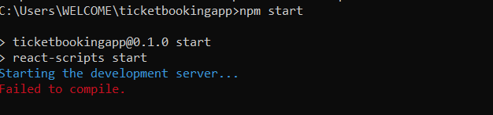

Step 9: Open a new browser window and type “localhost:3000” in the address bar

**Output:**

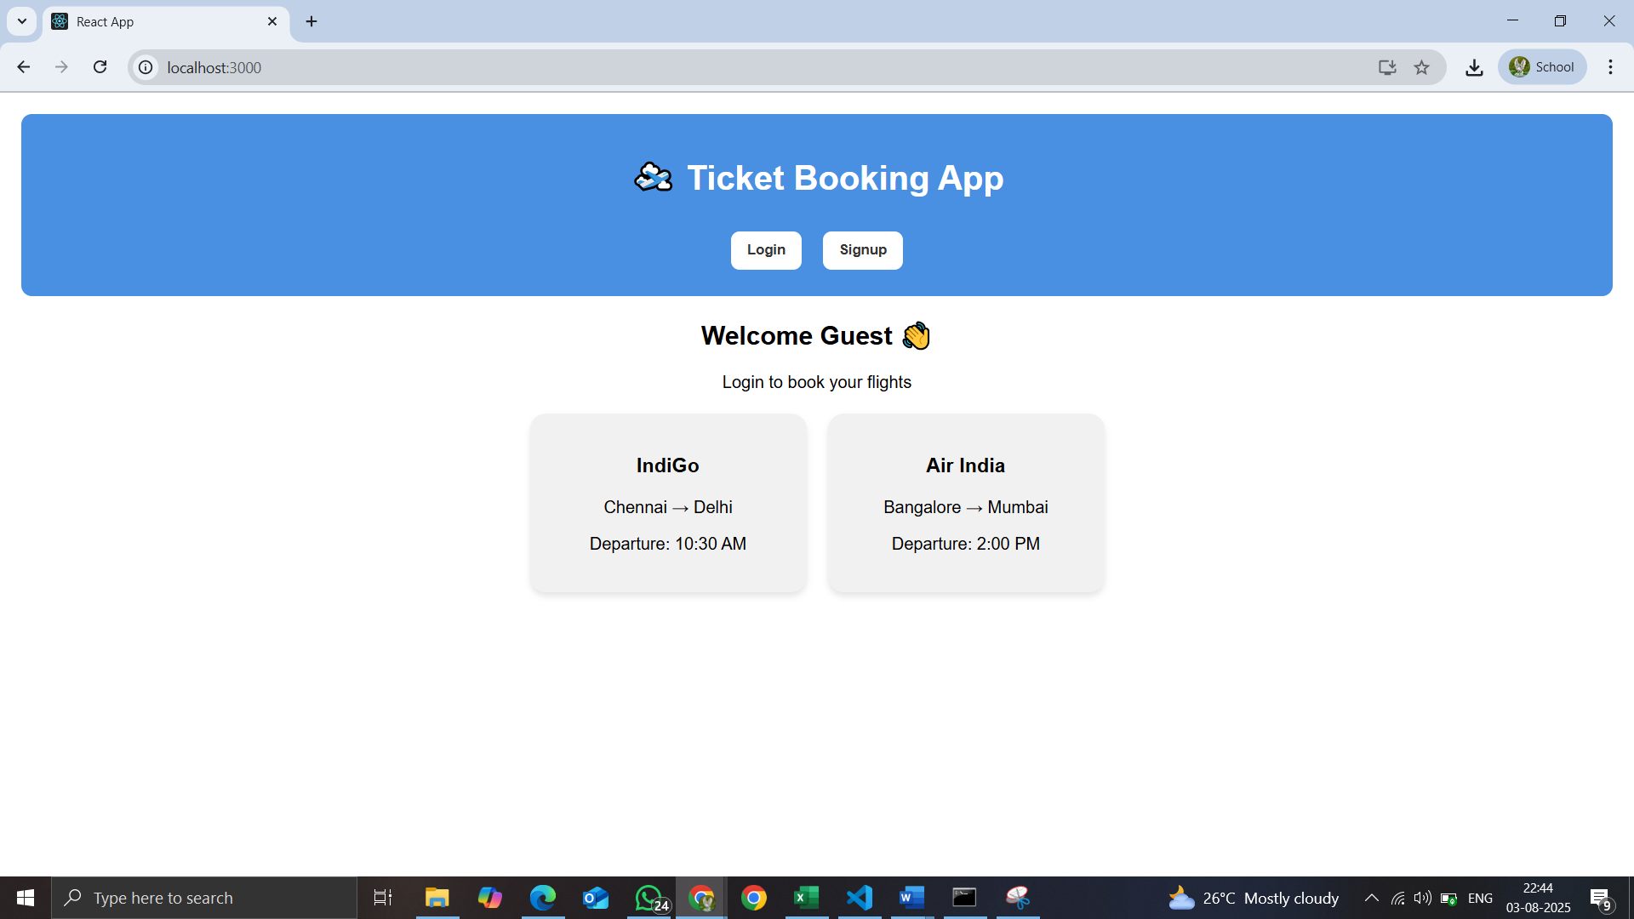

1. **SignUp**

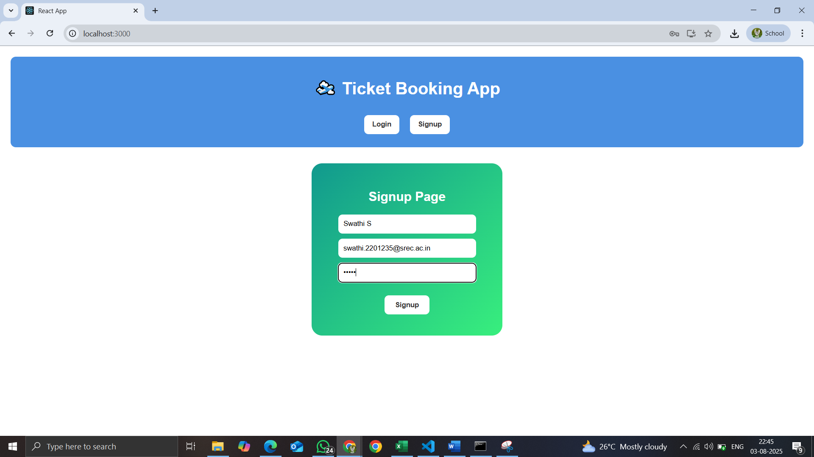

1. **Homepage**

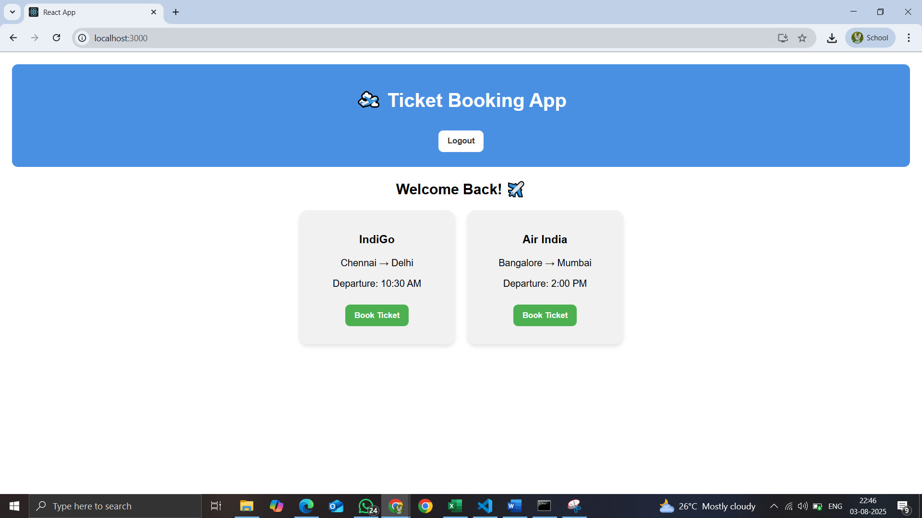

1. **Login page**

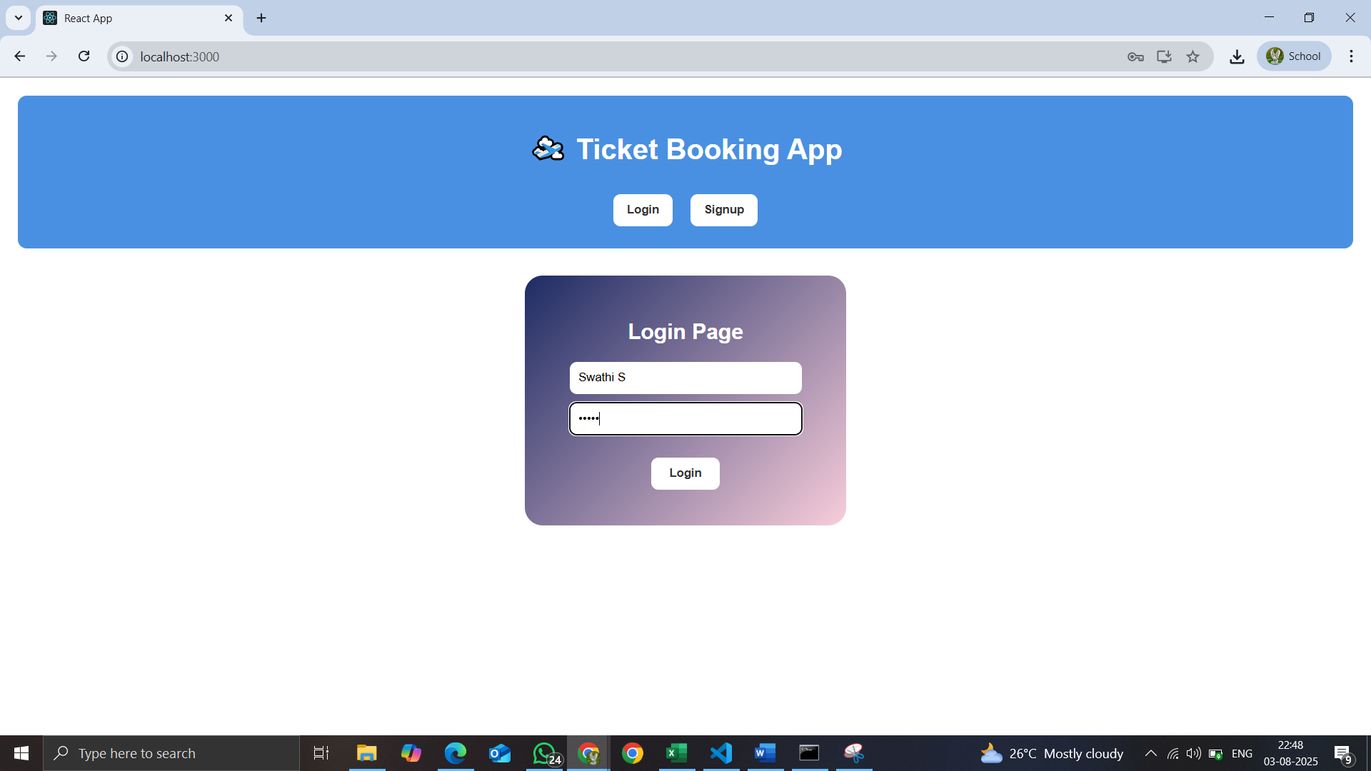

13. **ReactJS-HOL**

Create a React App named “bloggerapp” in with 3 components.

1. Book Details
2. Blog Details
3. Course Details

Implement this with as many ways possible of Conditional Rendering.

Step 1: To create a React Application with the name of “bloggerapp”, type the following command:

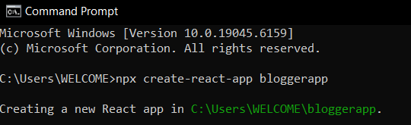

Step 2: Once the App is created, navigate into the folder of bloggerapp by typing the following command:



Step 3: Open the folder of bloggerapp in Visual Studio Code

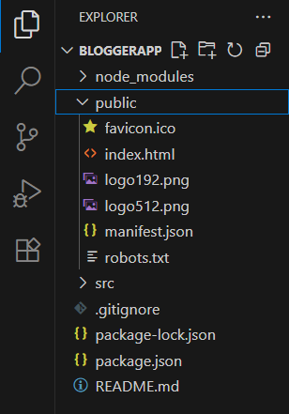

Step 4: Open the CourseDetails.js file in Src Folder of bloggerapp.Write the Code:

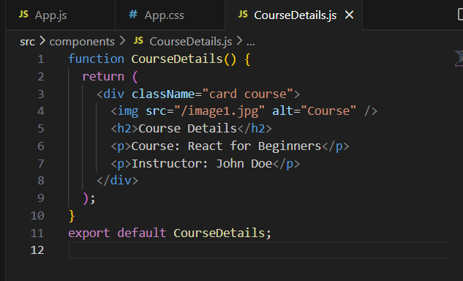

Step 5: Open the BookDetails.js file in Src Folder of bloggerapp.Write the Code.

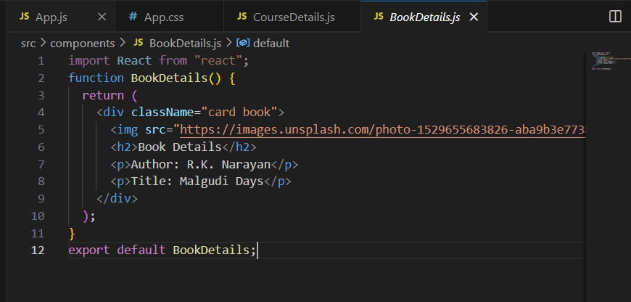

Step 6: Open the BlogDetails.js file in Src Folder of bloggerapp.Write the Code.

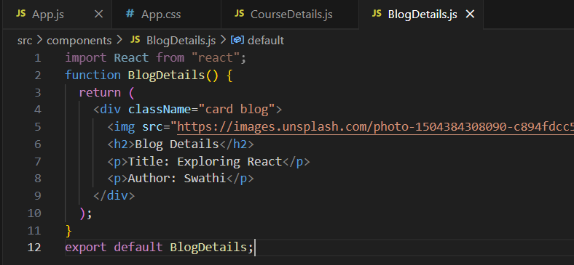

Step 7: Open the App.js file in Src Folder of bloggerapp.Write the Code

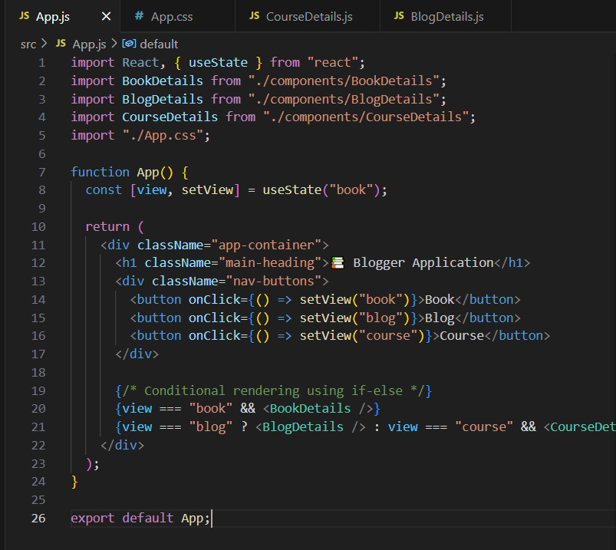

Step 8: Open the App.css file in Src Folder of bloggerapp.Write the Code

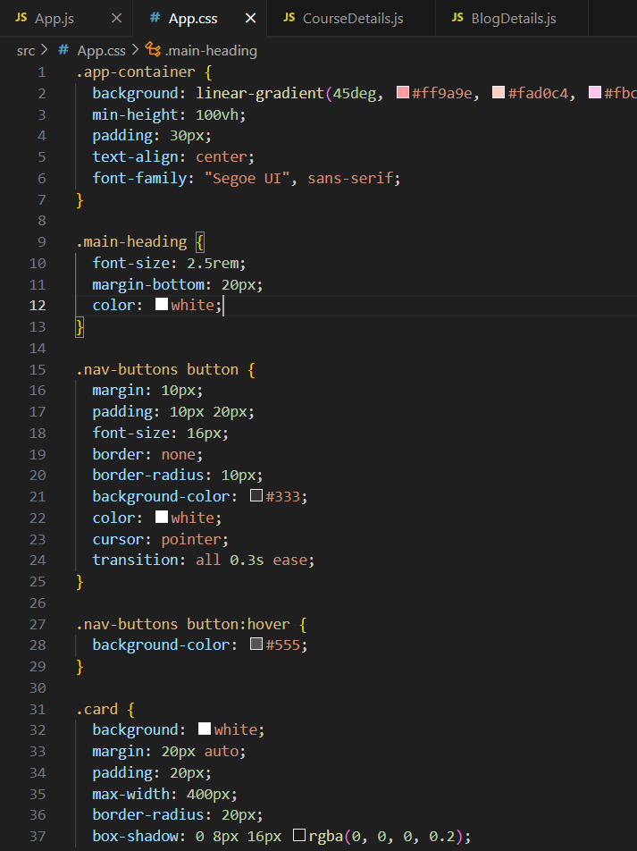

Step 9: Run the following command to execute the React application:

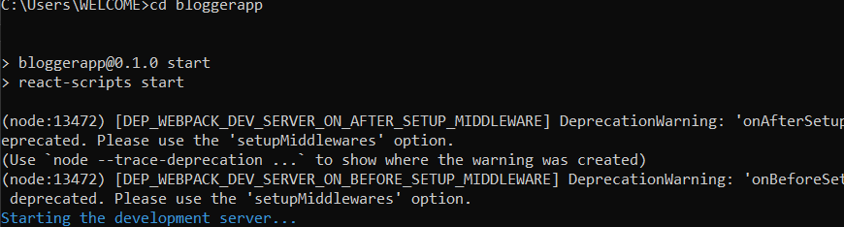

Step 10: Open a new browser window and type “localhost:3000” in the address bar

**Output:**

